Chapter 13:

Political, Cultural, and the Generational Motives

Omari Bryant

Takia Webster

Delta State University’s Department of Psychology

Learning Objectives:

1. Analyze the impact of political and cultural motives on individual behavior, with a focus on generational differences.
2. Evaluate the effectiveness of various **motivation** strategies in achieving organizational goals.
3. Apply critical thinking skills to identify and solve **motivation** challenges in a diverse workplace setting.
4. Analyze the impact of motives on decision-making, policy development, and conflict resolution in various contexts, such as international relations, domestic **politics**, and social movements.
5. Analyze the role of cultural motives in shaping human behavior, such as communication, cooperation, and conflict.
6. Analyze the impact of generational motives on social and cultural trends, such as technology adoption, work ethics, and political participation.

# Introduction:

Have you ever wondered why people behave the way they do at work? Do you ever find yourself struggling to motivate yourself or others to achieve a goal? Understanding **motivation** is a key component to success in the workplace. **Politics**, **culture**, and generational differences are three fundamental factors that shape the way we perceive the world around us. Each of these elements play a significant role in shaping our attitudes, beliefs, and behaviors, both individually and societal. Political motives refer to the beliefs and actions related to the exercise of power and governance within a particular society, while cultural motives encompass the values, norms, and practices that define a particular group's way of life. Generational motives, on the other hand, refer to the different attitudes and behaviors of people based on their age and life experiences. Understanding the interactions between these three factors is essential for comprehending the complex dynamics that underlie many social and political issues today. In this chapter, we will explore the complex nature of **motivation** and its influence on behavior, with a focus on political, cultural, and generational motives.

# Political Motives

Take a second to think about what you know about **politics** and what you know about **motivation**. Can you think of any similarity between the two? Political factors can have a significant impact on **motivation** in the workplace. Policies, laws, and regulations can create an environment that either supports or hinders **motivation**. For example, if a government imposes high taxes on businesses, it can lead to cost-cutting measures such as layoffs, reduced benefits, or lower salaries, which can negatively impact employee **motivation**. Similarly, if there are stringent labor laws that limit flexibility in scheduling or work arrangements, employees may feel frustrated and unmotivated.

On the other hand, political factors can also positively impact **motivation**. Government policies that promote equal opportunities, diversity, and inclusion can create a more supportive work environment that encourages **motivation**. For instance, if there are laws that mandate fair pay, provide access to education and training, and ensure a safe work environment, employees may feel more valued and invested in their jobs, which can improve **motivation**.

Now, let’s take a moment to look at a highly controversial topic in the United States today: the legalization of marijiuana. Political factors such as the legalization of marijuan can have a significant impact on **motivation** in the workplace. The decision to legalize marijuana often involves a complex mix of public opinion, government regulation, and economic factors. Legalization may be driven by public demand for decriminalization or the potential tax revenue generated by the marijuana industry. However, political factors such as conservative ideology or lobbying by the pharmaceutical industry may hinder legalization efforts. Let’s take a look at the impact marijuana has on **motivation** in the workplace. For employees who use marijuana recreationally or for medical reasons, the legalization of marijuana can reduce stress and anxiety related to potential disciplinary action or job loss. Additionally, legalization may allow employers to adopt more lenient drug policies or to focus on job performance rather than employee drug use. This can help to create a more positive work environment and enhance employee **motivation** and satisfaction. On the other hand, the legalization of marijuana may also lead to increased marijuana use, which can have negative effects on **motivation** and productivity. Employees who use marijuana heavily or frequently may experience decreased **motivation**, attention, and memory, which can impact job performance. The potential for addiction and other negative health effects may also impact employee **motivation** and well being. Employers may need to develop policies and procedures to address the use of marijuana on job performance and safety. This can impact **motivation** by creating a sense of uncertainty or anxiety among employees about the implications of marijuana use on their employment status. While political factors can impact **motivation** in a variety of ways, both positively and negatively, depending on the specific policies and regulations, the impact of marijuana legalization on **motivation** is complex and can be influenced by a variety of political, social, and environmental factors as well as many controversial political topics that we know of in today’s society.

## Barriers in the Workplace

Political barriers in the workplace can create a challenging environment for employees to navigate. Here are some strategies that can help overcome political barriers:

1. Foster open communication: Encourage open communication between employees and management to promote transparency and trust. This can be achieved through regular meetings, feedback sessions, and employee surveys.
2. Focus on common goals: Emphasize shared goals and values to reduce political tensions and create a more unified team. This can help employees focus on their work and the organization's success rather than personal agendas.
3. Encourage collaboration: Encourage collaboration and teamwork by providing opportunities for cross-functional teams to work together. This can help break down silos and promote a more cohesive **culture**.
4. Provide training: Provide training and development opportunities to help employees build skills and increase their knowledge. This can improve job satisfaction and reduce the likelihood of political conflicts.
5. Address conflicts directly: Address conflicts directly and quickly to prevent them from escalating. Encourage employees to seek resolution through open communication and respectful dialogue.

By implementing these strategies, organizations can help create a more positive and productive work environment that is focused on achieving common goals and promoting employee satisfaction.

## Political Motivation Tactics

Case Study 1: Patagonia’s “Vote the Planet” Campaign

In 2016, outdoor clothing company Patagonia launched its “Vote the Planet” campaign, aimed at motivating people to vote for candidates who support environmental protection. The company closed its retail stores and headquarters on election day to encourage employees and customers to vote, and donated 100% of its sales on Black Friday to grassroots environmental organizations. The campaign was successful in not only promoting environmental awareness but also motivating employees and customers to take action and vote for candidates who shared the company’s values.



Case Study 2: Starbucks’ “Race Together” Initiative

In 2015, Starbucks launched its “Race Together” initiative, aimed at encouraging conversations about race and diversity among employees and customers. The initiative involved baristas writing the phrase “Race Together” on coffee cups and inviting customers to discuss their perspectives on race relations. Despite some criticism and controversy, the initiative was successful in promoting open dialogue and increasing awareness of diversity issues in the workplace and in society as a whole.



# Cultural Motives

**Culture** plays an important role in shaping **motivation**. **Motivation** is influenced by cultural values, beliefs, and practices. For example, some **culture**s place a high value on individual achievement, while others prioritize collective goals. This can impact how individuals are motivated to work and what they consider to be meaningful accomplishments. Think about Collectivism vs. Individualism argument. In collectivist **culture**s, people tend to prioritize the goals and well-being of the group over their individual desires. In contrast, in individualistic **culture**s, such as those found in many Western countries, people tend to prioritize their own personal goals and desires. This difference can shape the types of goals and **motivation**s that are emphasized and valued in different **culture**s. Cultural differences can also affect the way individuals approach tasks and the level of effort they put into them. Some **culture**s value hard work and perseverance, while others prioritize balance and relaxation. This can lead to differences in work ethic and productivity. 

## 

## Creating Culturally-Sensitive Environments

1. Educate Employees: Conduct training sessions to educate employees about different **culture**s, including their customs, beliefs, and values. This can help promote understanding and respect among employees.
2. Encourage Communication: Encourage open communication among employees to foster a **culture** of **inclusivity**. This can be done by organizing events that encourage employees to share their **culture**s with others, such as food festivals or cultural awareness days.
3. Provide Language Support: Provide language support to employees who may have difficulty communicating in the primary language used in the workplace. This can include translation services, language classes, or hiring employees who are fluent in multiple languages.
4. Implement Policies and Procedures: Implement policies and procedures that promote diversity and **inclusivity** in the workplace. This can include anti-discrimination policies, equal opportunity hiring practices, and diverse representation on hiring and promotion committees.
5. Celebrate Diversity: Celebrate diversity in the workplace by recognizing and celebrating cultural events and holidays. This can help create a sense of belonging and inclusion among employees from different cultural backgrounds.

## A Look on Motivation and Culture

Sports: In many **culture**s, sports are seen as a way to build teamwork, camaraderie, and a sense of community. For example, in some Latin American countries, soccer is an important cultural activity that brings people together and instills a sense of national pride. The **motivation** to play and excel in sports can be driven by cultural values and traditions.

Education: Cultural differences can also impact **motivation** in the context of education. In some **culture**s, there is a strong emphasis on academic achievement and excellence. For example, in many East Asian countries, such as Japan and South Korea, there is a **culture** of high expectations for academic performance and a belief that hard work and dedication can lead to success. This cultural emphasis on education can drive **motivation** to excel in school and achieve academic success.

Health and Fitness: Cultural differences can also impact **motivation** when it comes to health and fitness. For example, in some **culture**s, there is a strong emphasis on physical fitness and maintaining a healthy lifestyle. In other **culture**s, there may be different values and priorities when it comes to health and wellness. These cultural differences can impact the **motivation** to engage in physical activity and make healthy lifestyle choices.



# Generational Motives

The impact of generational differences on **motivation** can extend beyond the workplace and affect various aspects of life. For example, Baby Boomers and older **generation**s may be motivated by the idea of retirement and financial security, while younger **generation**s such as Gen X, Millennials, and Gen Z may prioritize experiences, travel, and personal fulfillment. If you are either between the ages of 15-25, or know of someone between those ages, I am pretty sure you have heard of the term “lit,” right? I am almost positive none of our grandmothers used that term at all, but that goes to show you how different we are from **generation** to **generation**. In terms of leisure activities, older **generation**s may be motivated by traditional hobbies such as gardening or reading, while younger **generation**s may be motivated by social media or online gaming. Older **generation**s may be motivated by family and community connections, while younger **generation**s may prioritize individualism and personal growth. In terms of **politics** and social issues, generational differences can also impact **motivation**. For example, older **generation**s may be motivated by traditional values and may prioritize issues such as law and order, while **generation**s may be motivated by progressive values and prioritize issues such as climate change and social justice. Generational differences can impact **motivation** in various aspects of life and it is important to recognize and respect these differences in order to create a harmonious and inclusive society.

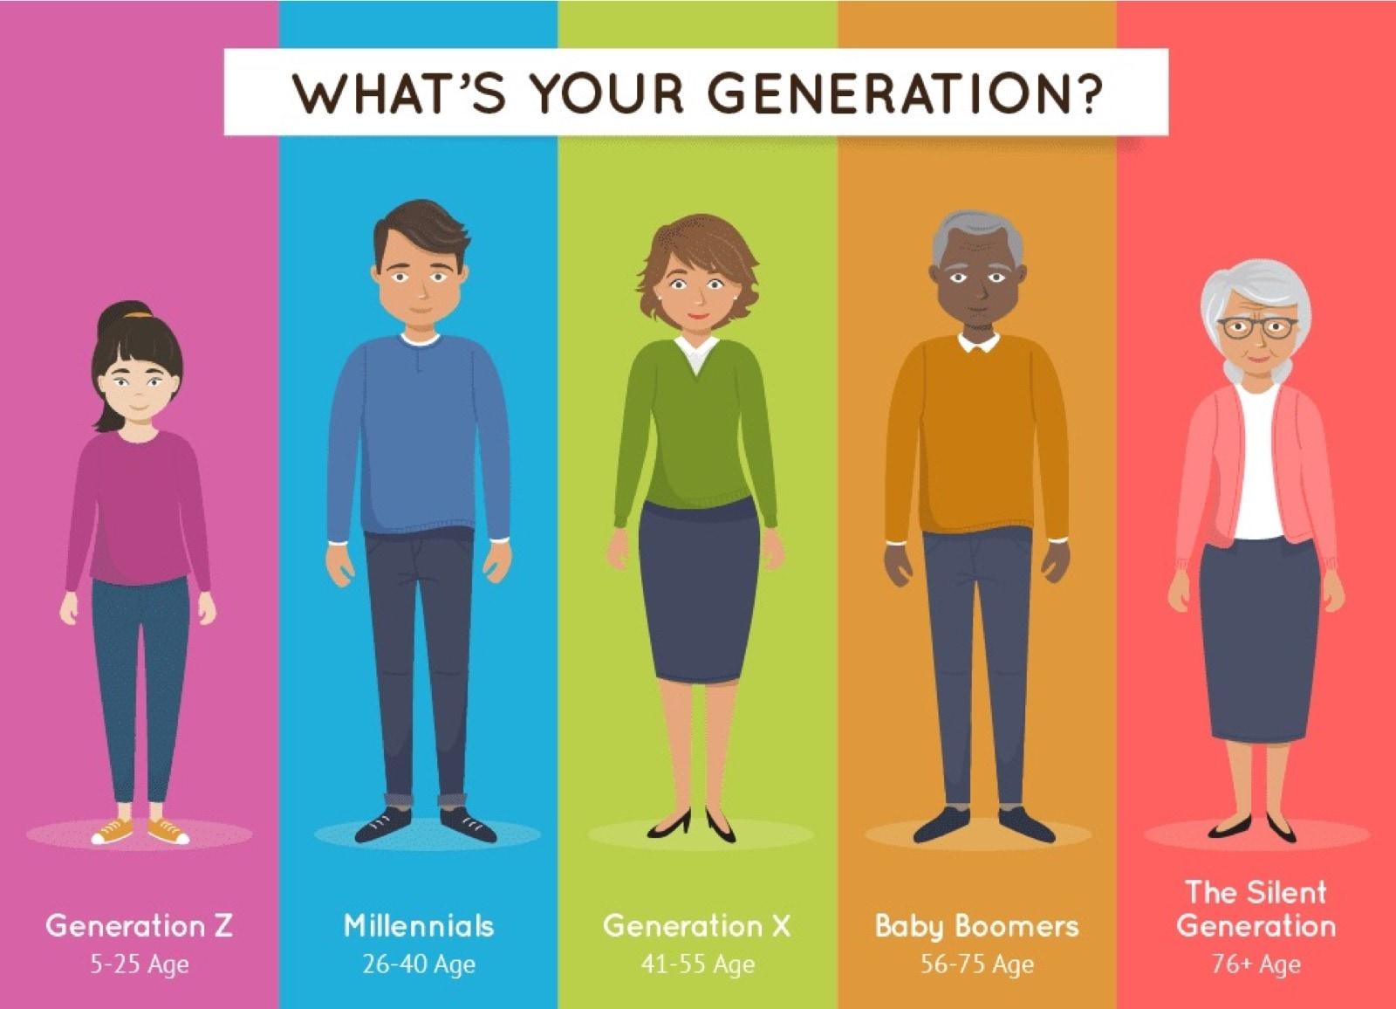

## Practices for Motivating Different Generations

1. Tailor communication: Each **generation** has their preferred mode of communication. For example, millennials prefer texting and social media, while baby boomers prefer phone calls and face-to-face conversations. Tailoring communication to meet the preferences of different **generation**s can help ensure messages are received and understood.
2. Create shared experiences: Shared experiences that appeal to different **generation**s can help build a sense of community and shared purpose. For example, organizing a community service project or a family outing can bring together different **generation**s and create a sense of belonging.
3. Recognize and celebrate differences: Each **generation** has their unique values and perspectives. Recognizing and celebrating these differences can create a sense of appreciation and respect for each other’s backgrounds and experiences.
4. Use technology to bridge the gap: Technology can be used to bridge the gap between different **generation**s. For example, using video conferencing to connect with distant family members or organizing virtual events can help bring people together across different **generation**s and locations.
5. Provide opportunities for growth and development: Different **generation**s may have different goals and aspirations. Providing opportunities for growth and development can help motivate individuals to pursue their goals and feel a sense of fulfillment.



## Successful Intergenerational Motivation

Starbucks:

In 2015, Starbucks launched a program called “Pathway to the American Dream” aimed at hiring and training young people who are not in school or employed, as well as veterans and military spouses. This program targeted individuals from diverse backgrounds, including various age groups. The program was designed to help participants develop workplace skills and gain experience, with the ultimate goal of building a long-term career with Starbucks. The program’s success was due in part to its emphasis on mentorship and support from more experienced employees, who served as coaches and guides for the program participants. By creating a **culture** of inclusion and support, Starbucks was able to motivate and engage employees from different **generation**s and backgrounds.

PwC:

PwC, a global professional services firm, has implemented several programs to promote intergenerational collaboration and knowledge sharing. One such program is the “Reverse Mentoring” initiative, in which younger employees are paired with senior executives to share knowledge about new technologies, trends, and perspectives. This program has helped to break down generational barriers and promote innovation within the company. Additionally, PwC has established several employee resource groups, including groups focused on age and generational diversity. These groups provide a platform for employees to connect and collaborate across **generation**s, sharing their unique experiences and perspectives. By promoting intergenerational collaboration and creating a supportive and inclusive work environment, PwC has successfully motivated employees from different **generation**s.

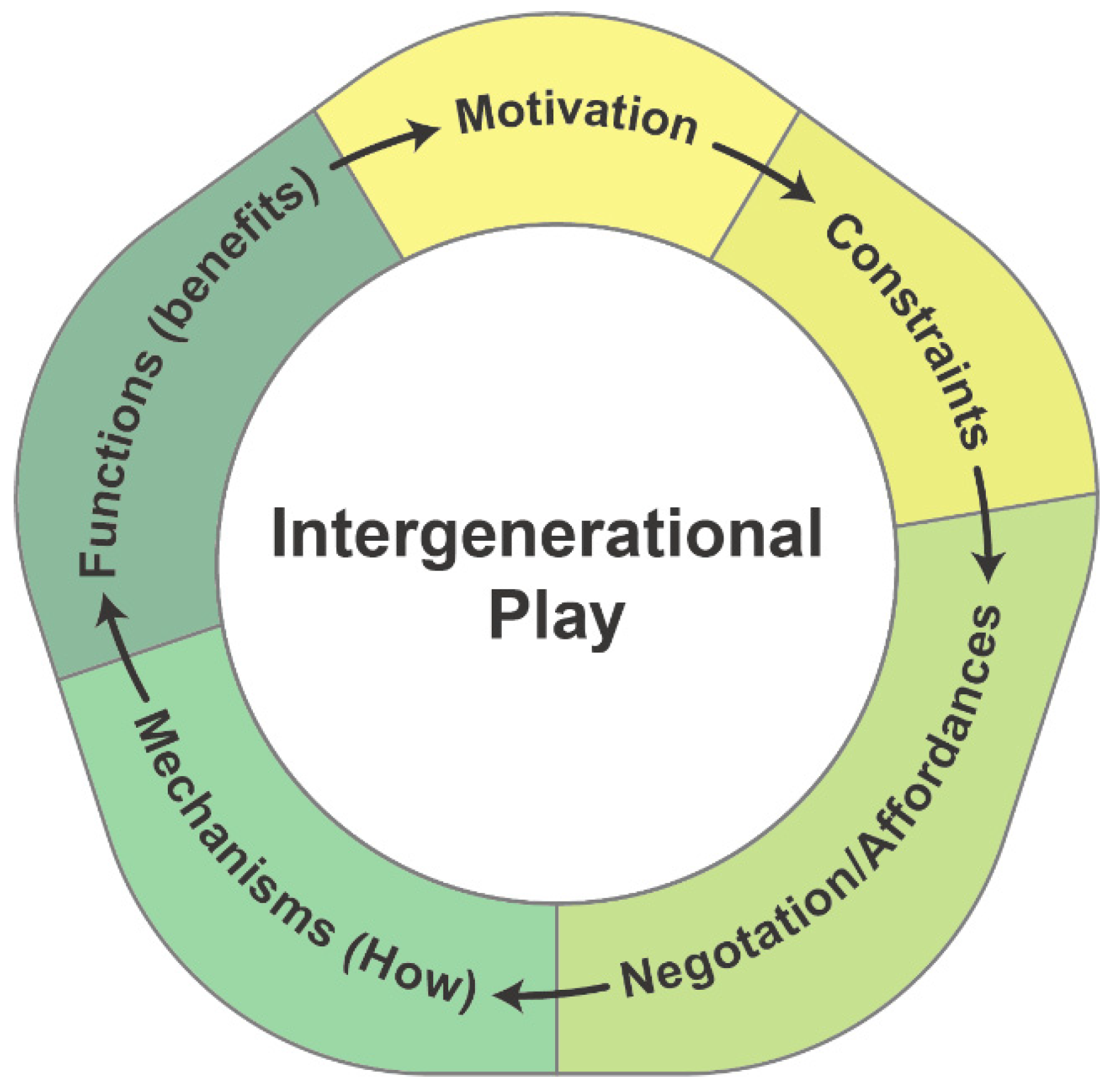

In this chapter, we have explored the importance of **motivation** in the workplace and outside of the workplace, with a focus on political, cultural, and generational motives. We have learned that **motivation** is a complex and multifaceted phenomenon that requires careful consideration of individual differences and cultural context. Two major takeaways from this chapter include the importance of creating culturally-sensitive environments and tailoring motivational strategies to different **generation**s. By understanding the complex nature of **motivation**, we can create a more inclusive and effective world.

## Discussion Activity:

1. How do political and cultural factors impact your motivations at your job?
2. Can you think of any examples of successful intergenerational motivation?
3. What strategies have you found to be most effective in overcoming political or cultural barriers to motivation?

## Key Terms:

* Motivation
* Politics
* Culture
* Generation
* Inclusivity

## Key Take-Aways:

* Understanding the complex nature of motivation is essential for success in the workplace.
* Political, cultural, and generational factors play a significant role in shaping motivation.
* Creating a culturally-sensitive work environment and tailoring motivational strategies to different generations are key components of effective motivation.

## Knowledge Questions:

1. How would you create a culturally-sensitive work environment?
2. Can you identify a successful political motivation tactic used in a workplace?
3. How would you tailor a motivational strategy to a specific generation?

## Key Terms and Definitions:

1. Motivation: The driving force or reason behind an individual’s behavior, action or effort towards achieving a goal or satisfying a need.
2. Politics: The activities associated with the governance of a country or area, particularly the debate between parties having power.
3. Culture: The set of shared values, beliefs, behaviors, and artifacts that characterize a group or society. Culture influences how people interact with each other, as well as how they view the world and approach tasks.
4. Generation: A group of people born and living during the same time period, who share common experiences, values, and beliefs.
5. Inclusivity: The practice or policy of ensuring that all individuals feel values, respected, and welcome in a particular setting, regardless of their race, gender, sexual orientation, age, ability, or other personal characteristics.